PROJECT DOCUMENTATION
Implement Client Script & UI Policy (Incident)
Functional and technical documentation (FSD format)
Team ID | 9100Orbit
Project Name | Implement Client Script & UI Policy (Incident)
Platform | ServiceNow (Incident Management)
Date | 08 October 2026

1. Introduction
Project Title | Implement Client Script & UI Policy (Incident)
Team ID | 9100Orbit
Team Members
Name | Role
To be added by the team | To be added
To be added by the team | To be added
To be added by the team | To be added
To be added by the team | To be added
Note on format: the documentation format is written for MERN projects (React, Node.js, Express.js, MongoDB). This project is built on the ServiceNow platform, so each MERN-specific section below is mapped to its ServiceNow equivalent, and sections that do not apply say so clearly.

2. Project Overview

Purpose
Incident records need consistent and accurate data to support triage, routing and resolution. Relying only on user awareness and manual checks can lead to incomplete, inconsistent or incorrect data, which affects reporting accuracy and SLA compliance. This project shows how ServiceNow UI Policies and Client Scripts enforce data integrity on Incident records directly on the form and list.
Goals:
- Make fields mandatory, read-only or auto-populated based on the Impact value.
- Block saving of High-impact incidents that have no assigned person.
- Block accidental State changes from the list view.
- Improve data quality and consistency across the platform.

Features
Feature | Description | Implemented with
Mandatory Assignment group | When Impact is 1 - High, Assignment group becomes mandatory | UI Policy action
Read-only Urgency | When Impact is 1 - High, Urgency cannot be edited | UI Policy action
Reverse behavior | Mandatory and read-only effects are removed when Impact is no longer High | Reverse if false
Auto-set Urgency | Urgency is set to 1 - High and an info message is shown when Impact becomes High | onChange client script
Save validation | A High-impact incident cannot be saved without Assigned To; an error is shown on the field | onSubmit client script
List edit block | State cannot be changed directly in the list; an alert is shown | onCellEdit client script

3. Architecture
Mapping of the MERN layers to this project:
MERN layer | In this project
Frontend (React) | ServiceNow Platform UI: the Incident form and Incident list in the browser, with UI Policy and Client Scripts running on the client side
Backend (Node.js and Express.js) | ServiceNow platform application server. No custom server code was written
Database (MongoDB) | ServiceNow relational database on the cloud instance (incident table and rule definition tables)
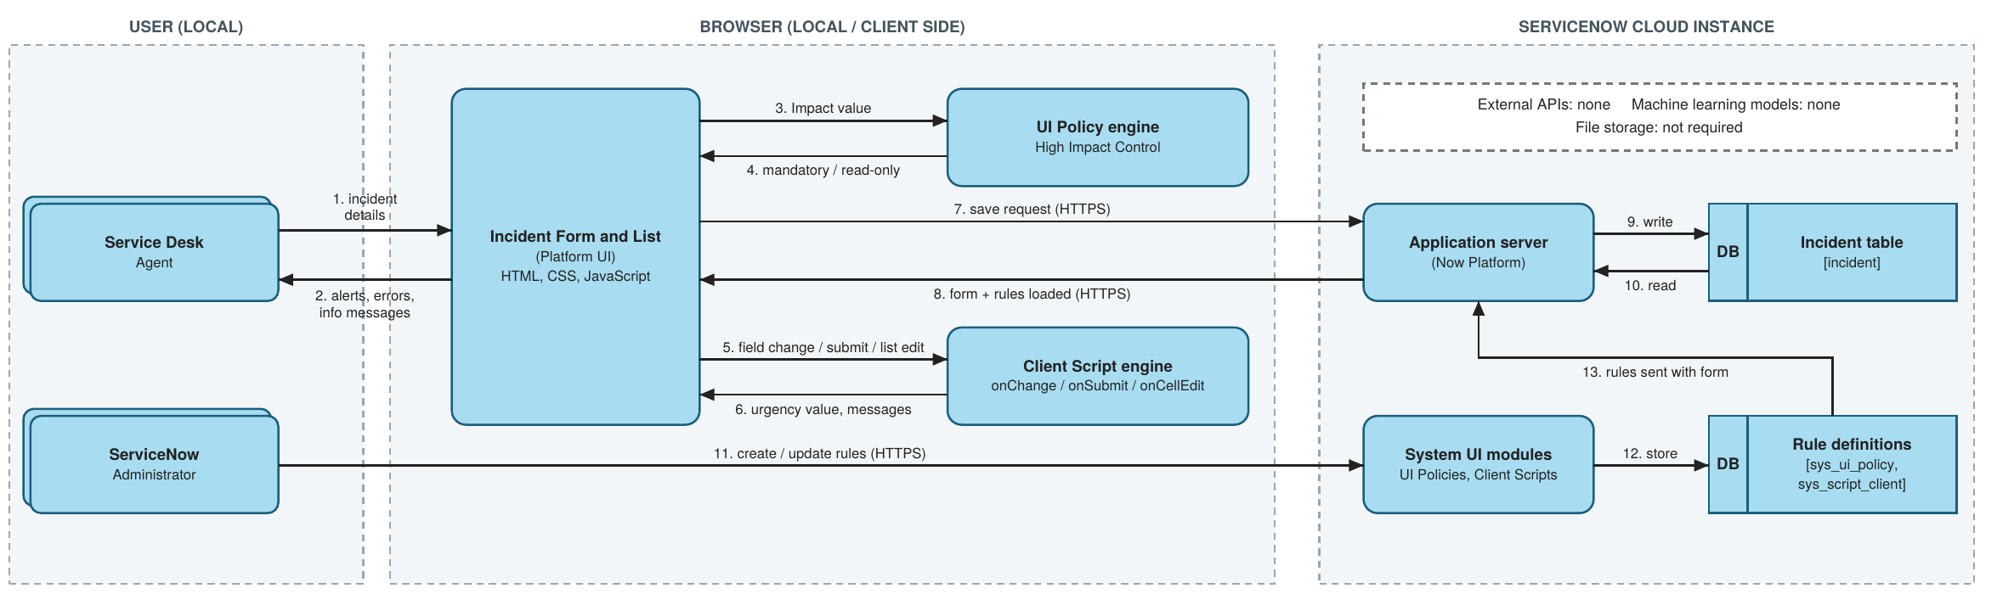
Figure 3.1: Technical architecture

Frontend
The user interface is the standard ServiceNow Incident form and list. The behavior of the form is controlled by the following client-side components, all on the Incident table:
Component | Type | Trigger | Behavior
High Impact Control | UI Policy (Global, On load, Reverse if false) | Impact is 1 - High | Assignment group mandatory; Urgency read-only (UI Policy actions)
Auto set urgency for high impact | Client Script - onChange | Field: Impact | Sets Urgency to 1 and shows an info message when Impact is 1; ignores form load and empty values
Prevent save if Assigned To missing | Client Script - onSubmit | Submit / Update | Returns false and shows an error box when Impact is 1 and Assigned To is empty
Prevent state change via list edit | Client Script - onCellEdit | Field: State (list) | Shows an alert and calls callback(false) to cancel the edit

Backend
The ServiceNow platform application server receives the saved record and writes it to the database. This project adds no custom server-side code: no business rules, script includes or REST endpoints were created, and no Node.js or Express.js is used. Because of this, the rules in this project apply only when users work in the browser interface.

Database
Data is stored in the ServiceNow relational database. The tables and fields used are:
Table | Purpose | Fields used
incident | Stores Incident records | number, caller, category, state, impact, urgency, priority, assignment_group, assigned_to, short_description
sys_ui_policy | Stores the UI Policy "High Impact Control" | short description, table, active, conditions, reverse if false, on load, global
sys_ui_policy_action | Stores the UI Policy actions | field name (assignment_group, urgency), mandatory, read only, visible
sys_script_client | Stores the three client scripts | name, table, type, field name, active, script
Key field values: impact and urgency use 1 = High, 2 = Medium, 3 = Low. Priority is calculated by the platform from Impact and Urgency (for example, Impact 1 and Urgency 1 give Priority 1 - Critical). The assigned_to and assignment_group fields are references to user and group records.

4. Setup Instructions

Prerequisites
- A ServiceNow instance. A Personal Developer Instance from developer.servicenow.com can be used (the screenshots in this document are from a developer instance).
- A user account with administrative or configuration access.
- A modern web browser such as Chrome or Edge.
- No Node.js, MongoDB or other local software is needed.

Installation
There is nothing to clone or install and there are no environment variables. The solution is created by configuring records on the instance:
- Log in to the instance with administrative or configuration access.
- Go to System UI > UI Policies and click New. Set Short description to "High Impact Control", Table to Incident and Active to true.
- Set the condition to Impact is 1 - High and tick Reverse if false. Submit the policy.
- Under UI Policy Actions, add an action for Assignment group with Mandatory = True. Add a second action for Urgency with Read only = True. Leave Visible unchanged.
- Go to Client Scripts and click New. Create "Auto set urgency for high impact" (Table: Incident, Type: onChange, Field: Impact, Active: true) and paste the onChange script from the Appendix of the Final Report.
- Create "Prevent save if Assigned To missing" (Table: Incident, Type: onSubmit, Active: true) and paste the onSubmit script.
- Create "Prevent state change via list edit" (Table: Incident, Type: onCellEdit, Field: State, Active: true) and paste the onCellEdit script.

5. Folder Structure
ServiceNow stores configuration as records in tables, not as files and folders. The structure below shows where each part of the solution is found on the instance:
ServiceNow instance (Global application scope)
|-- Client (browser side)
| |-- System UI > UI Policies
| | +-- High Impact Control (table: Incident)
| | |-- Action: Assignment group (mandatory = true)
| | +-- Action: Urgency (read only = true)
| +-- Client Scripts
| |-- Auto set urgency for high impact (onChange, field: Impact)
| |-- Prevent save if Assigned To missing (onSubmit)
| +-- Prevent state change via list edit (onCellEdit, field: State)
+-- Server (platform side)
+-- Database tables: incident, sys_ui_policy,
sys_ui_policy_action, sys_script_client

6. Running the Application
There are no start commands. The platform runs on the cloud instance and the rules are active as soon as they are saved.
MERN step | This project
Frontend: npm start in the client directory | Open the instance in the browser and go to Incident > Create New (form) or Incident > All (list)
Backend: npm start in the server directory | Not needed. The ServiceNow platform is always running on the cloud instance
To see the solution working:
- Go to Incident > Create New and select Impact 1 - High. Urgency changes to 1 - High and becomes read-only, and Assignment group becomes mandatory.
- Leave Assigned To empty and click Submit. The save is blocked and an error appears on Assigned To.
- Select a user in Assigned To and click Submit. The incident saves.
- Open the incident, change Impact to 2 - Medium. Assigned To is no longer mandatory and Urgency is editable.
- Go to Incident > All and double-click State in a row. An alert appears and State does not change.

7. API Documentation
This project does not create any custom REST endpoints. The "interfaces" it uses are the ServiceNow client-side GlideForm methods and the list-edit callback:
Method | Used in | Parameters | Purpose
g_form.getValue(field) | onSubmit | field name, e.g. impact, assigned_to | Read the current value of a field
g_form.setValue(field, value) | onChange | urgency, 1 | Set Urgency to 1 - High
g_form.addInfoMessage(text) | onChange | message text | Show an info message at the top of the form
g_form.showErrorBox(field, text) | onSubmit | assigned_to, message text | Show an error under the field
return false / return true | onSubmit | none | Block or allow the save
callback(false) | onCellEdit | false | Cancel the list edit
Platform REST API (not used by this project): ServiceNow provides a built-in Table API, for example GET, POST and PATCH on /api/now/table/incident, which returns JSON in a result object. Requests sent through an API do not run client scripts or UI Policies, so records created this way are not checked by the rules in this project. Server-side rules would be needed to cover them (see Future Enhancements).

8. Authentication
- Users sign in to the ServiceNow instance with their own credentials. The platform manages the login session; this project adds no custom login, tokens or JWT handling.
- Authorization is role-based. Only users with administrative or configuration access can create or change UI Policies and Client Scripts.
- Access to Incident records is controlled by the platform access controls (ACLs) already configured on the instance. This project does not change them.
- The client scripts run in isolated (strict) script mode, which blocks direct access to the page DOM.
- Organizations can add single sign-on or multi-factor authentication at the platform level; this was not part of the project.

9. User Interface
The screens below show how the Incident form and list behave with the rules in place.
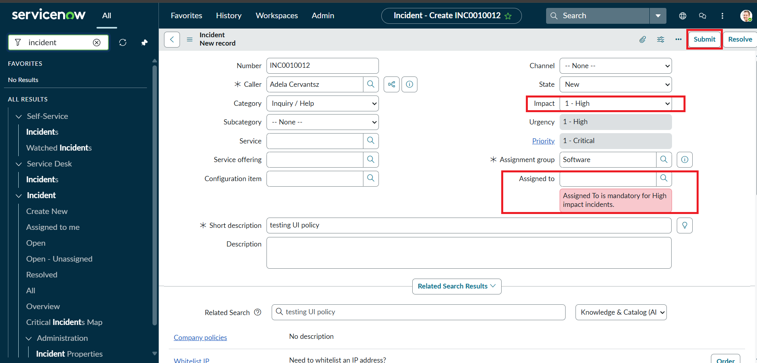
Figure 9.1: Incident form - High impact, Assigned To empty, error shown on save
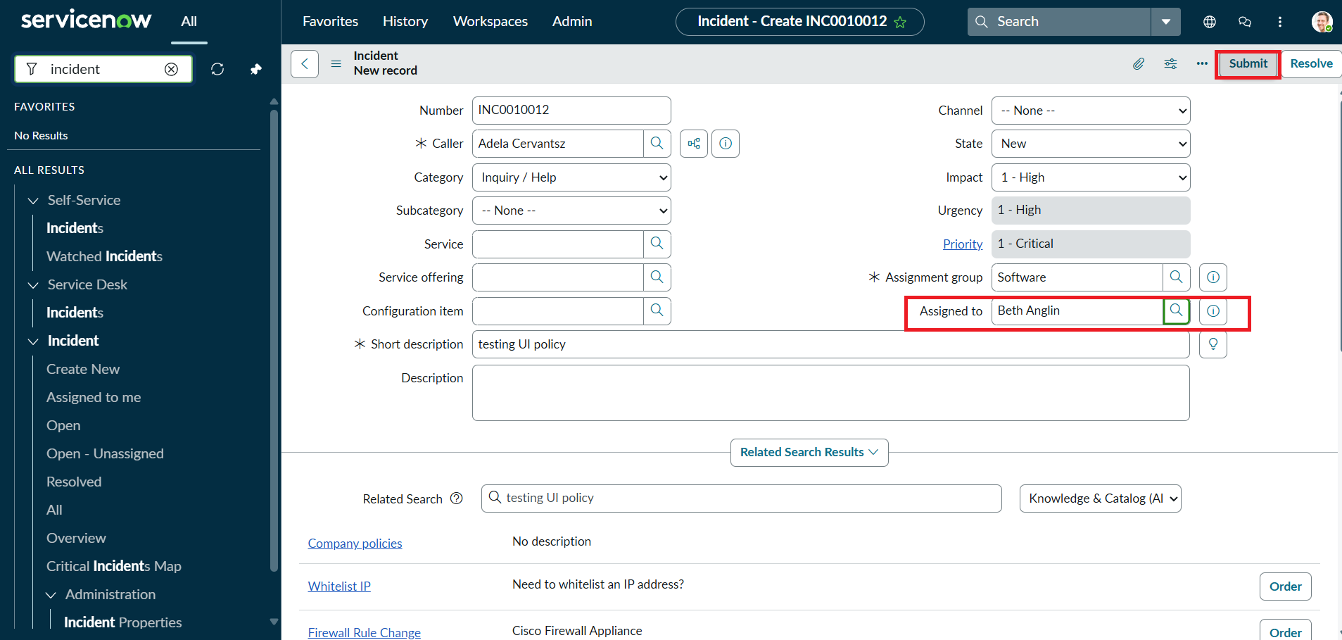
Figure 9.2: Incident form - Assigned To filled and incident saved
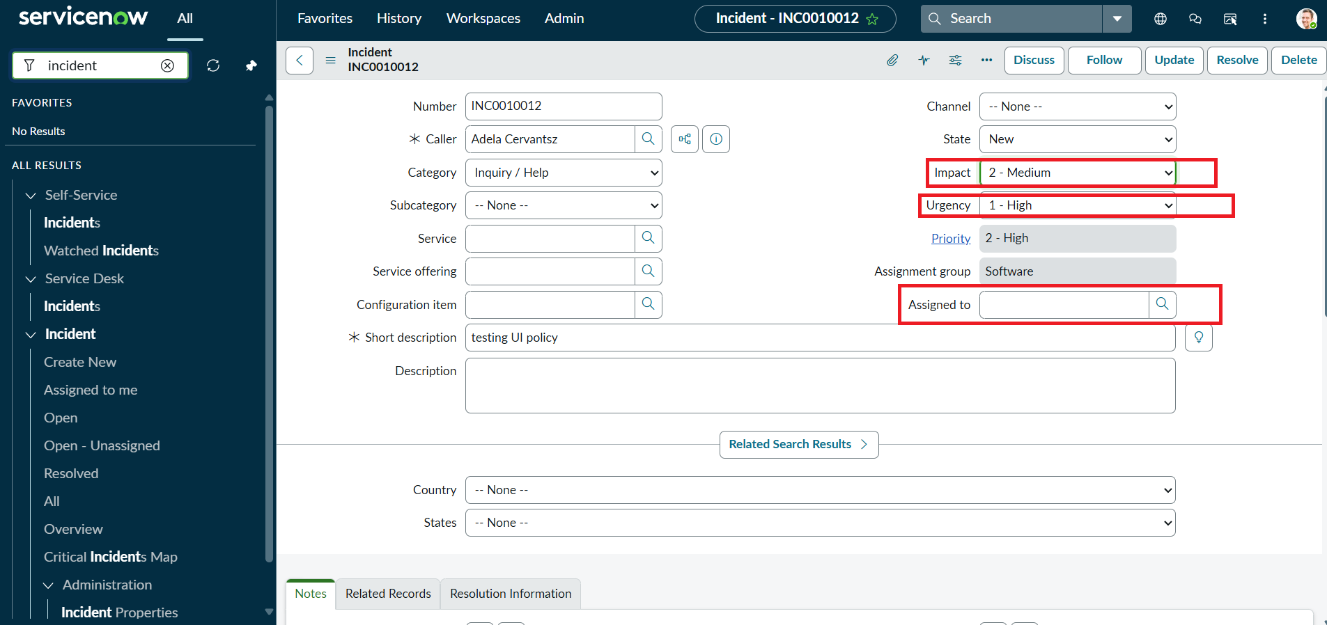
Figure 9.3: Incident form - Impact changed to Medium, Assigned To optional
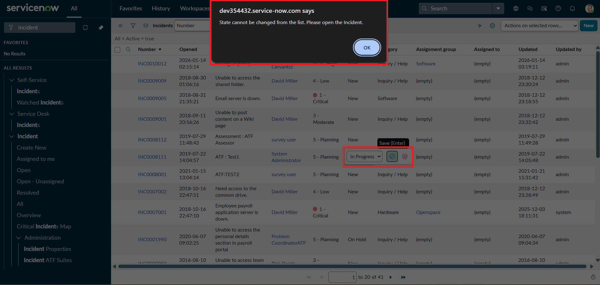
Figure 9.4: Incident list - alert shown when State is edited
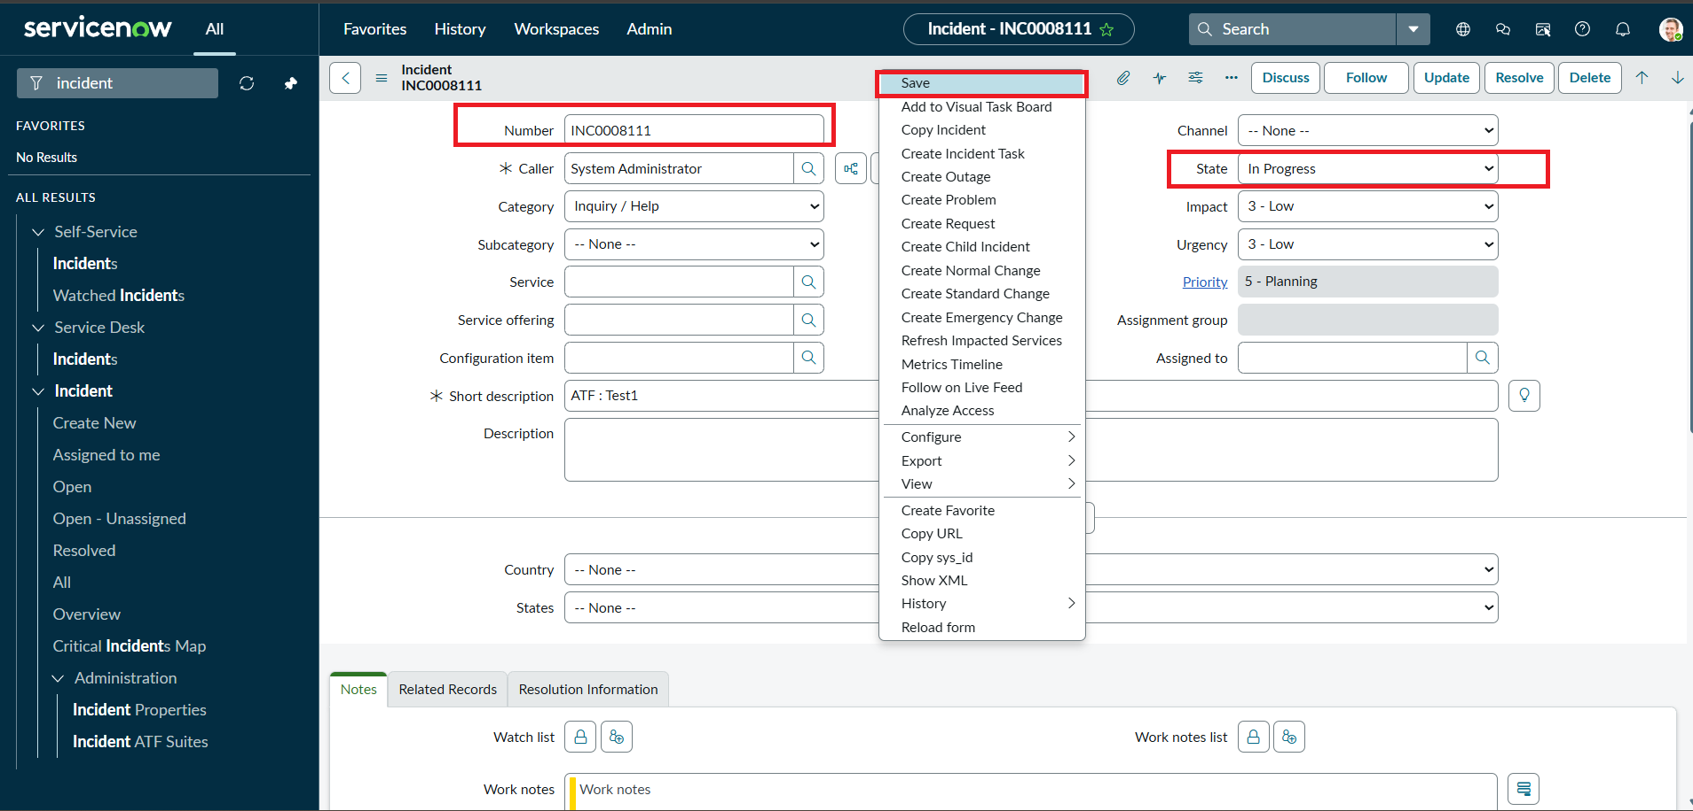
Figure 9.5: Incident form - State updated from the form

10. Testing

Testing strategy
Manual functional testing was done on the ServiceNow instance. Each rule was tested in the situation where it should apply and where it should not apply, including the reverse condition and the difference between the list and the form. Results were recorded with screenshots.

Tools used
- ServiceNow instance (Incident form and list)
- Web browser
- No automated tests were created (for example, ServiceNow Automated Test Framework was not used).

Test cases
Test ID | Scenario | Expected result | Actual result | Status
TC-1 | Set Impact to 1 - High on a new incident | Assignment group becomes mandatory | Assignment group shown as mandatory | Pass
TC-2 | Set Impact to 1 - High | Urgency becomes read-only | Urgency shown greyed out and not editable | Pass
TC-3 | Change Impact to 1 - High (onChange) | Urgency set to 1 - High with info message | Urgency set to 1 - High automatically | Pass
TC-4 | Save a High-impact incident with Assigned To empty (onSubmit) | Save blocked, error shown on Assigned To | Incident not saved; error "Assigned To is mandatory for High impact incidents." shown | Pass
TC-5 | Fill Assigned To and click Submit | Incident saves without errors | Incident saved successfully | Pass
TC-6 | Change Impact from High to Medium on an existing incident | Assigned To optional, Urgency editable, record saves | Restrictions removed and record saves | Pass
TC-7 | Double-click State in the Incident list (onCellEdit) | Alert shown and State unchanged | Alert shown; State unchanged | Pass
TC-8 | Change State on the Incident form and click Update | State change saves | State saved as In Progress | Pass

11. Screenshots or Demo
Configuration screenshots from the instance:
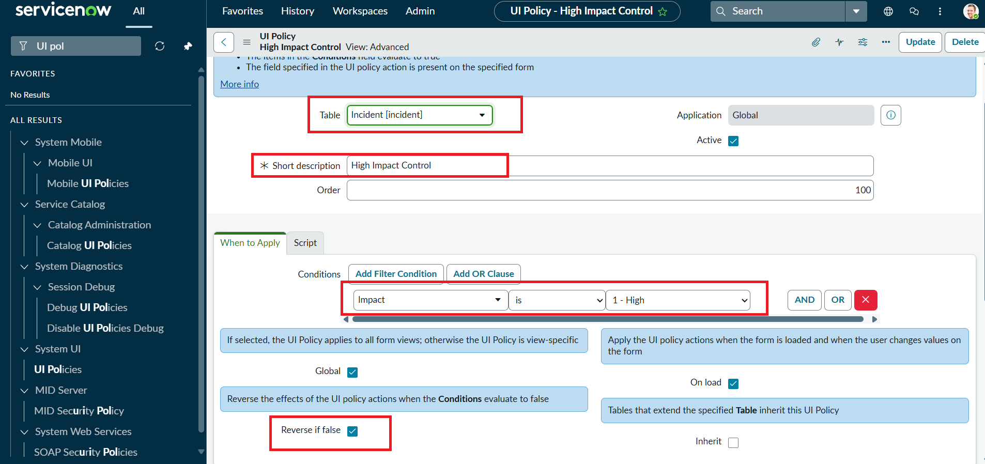
Figure 11.1: UI Policy "High Impact Control"
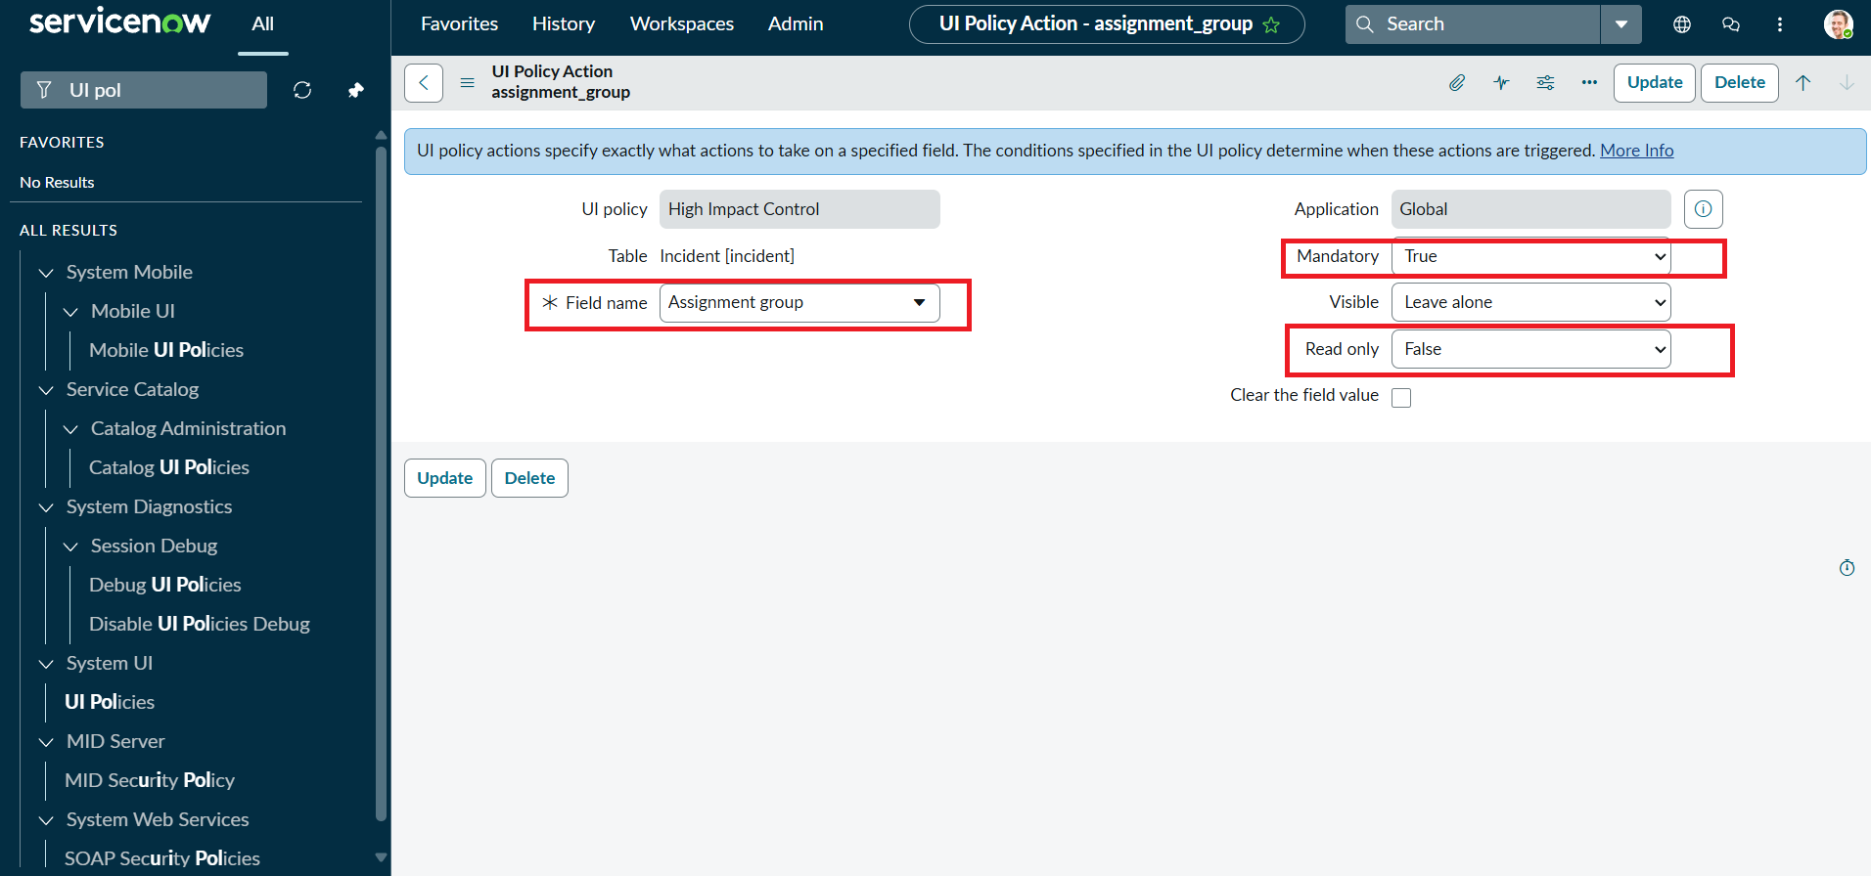
Figure 11.2: UI Policy action - Assignment group mandatory
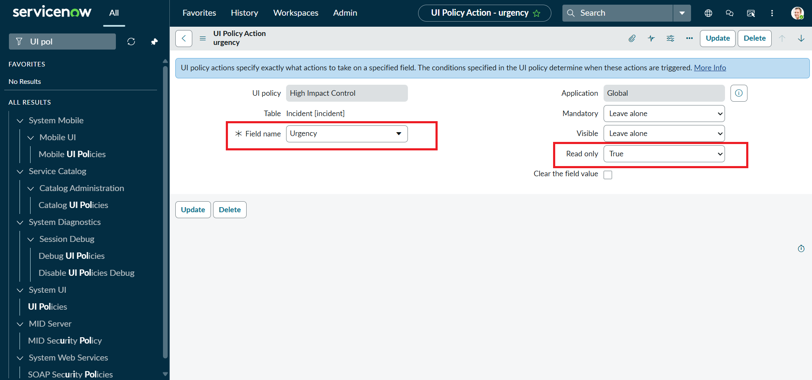
Figure 11.3: UI Policy action - Urgency read-only
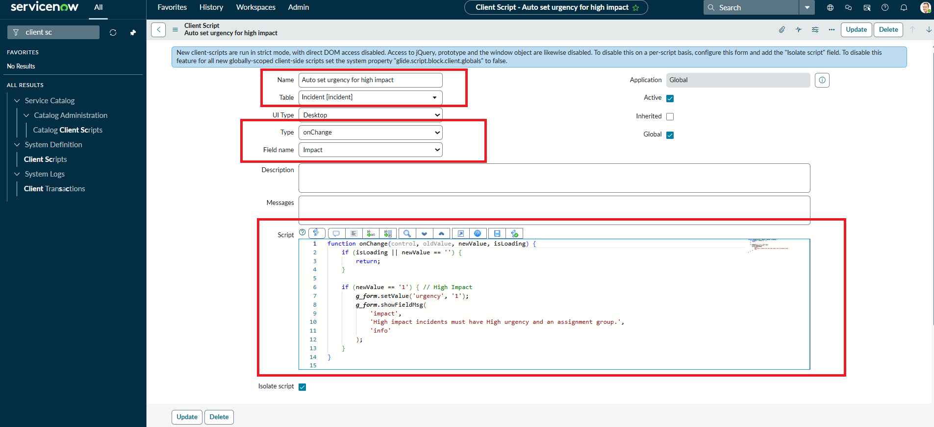
Figure 11.4: onChange client script
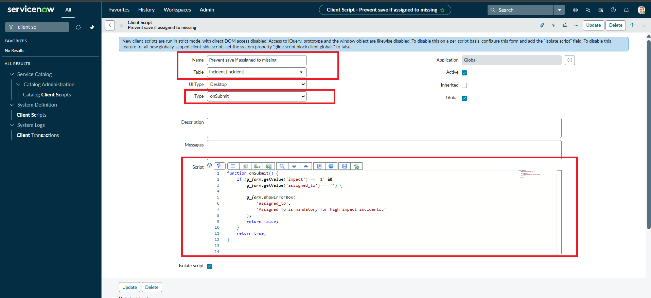
Figure 11.5: onSubmit client script
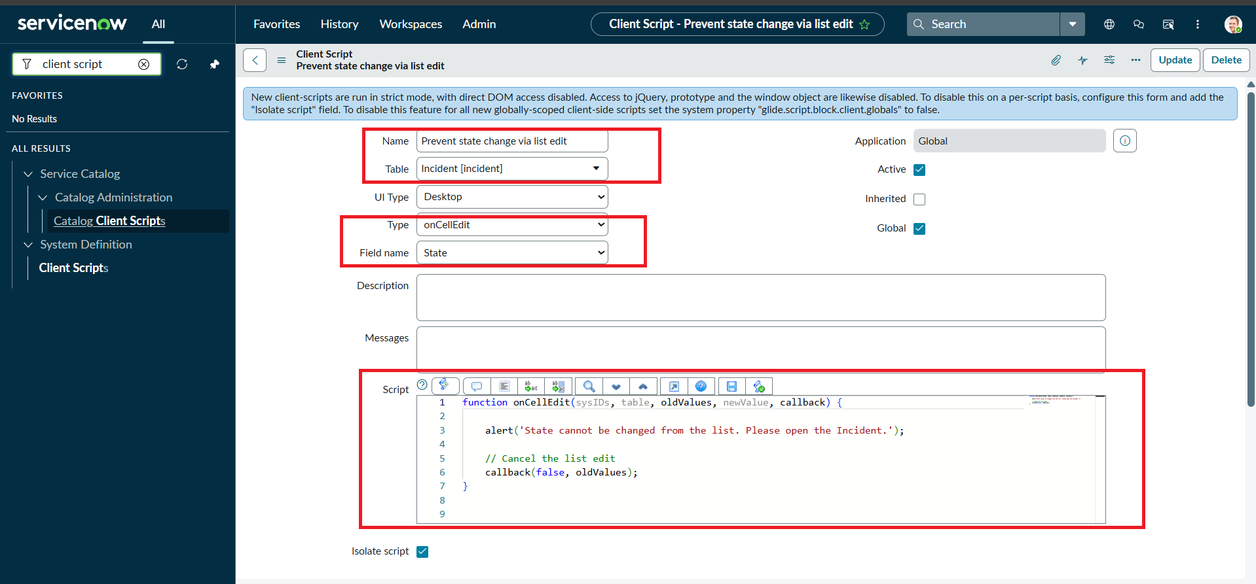
Figure 11.6: onCellEdit client script
Demo link: to be added by the team

12. Known Issues
- Client-side rules do not apply to integrations, imports, API calls or background updates, so these can create High-impact incidents without Assigned To.
- The onCellEdit script blocks every State edit in the list for all users, with no role-based exception.
- When Impact is lowered from High, Urgency stays at its earlier value; it becomes editable but is not reset.
- The value "1" for High and the message texts are written in the scripts, so changing them needs a script edit.
- The scripts apply to the Desktop UI type only.

13. Future Enhancements
- Add server-side business rules or data policies so the same checks apply to every way of creating or updating an incident.
- Allow role-based exceptions for the list-edit block, for example for managers.
- Reset or recalculate Urgency when Impact is lowered.
- Move hard-coded values and messages into system properties or message records.
- Extend the controls to other tables such as Problem and Change.
- Create automated tests for the rules.

